VLANs should be deployed to both nodes of a HA pair Repeat these steps on both nodes.

Request IP in banana for the new VLAN, 1 per filer. During this process also create a DNS entry in the format of <Filer>-<corp/ecom>vsip-<VLAN>.int.thomsonreuters.com
- eg-naslowcp-h03-corpvsip-2504.int.thomsonreuters.com

Add the vlan to the filer with: ssh <filer> vlan add <interface> <VLAN>
- ssh eg-naslowcp-h03 vlan add corpvif0 2504

Create ipspace with: ssh <filer> ipspace create <ipspacename> <interface>
- ssh eg-naslowcp-h03 ipspace create corp-2504 corpvif0-2504

Wait at least 30 minutes for WFA to update VLAN/ipspace details.

Create vFiler via WFA on each node with the hostname <Filer>-<corp/ecom>vsip-<VLAN>. Use “TR Create vFiler Only – NFS” and select all the appropriate options
- eg-naslowcp-h03-corpvsip-2504
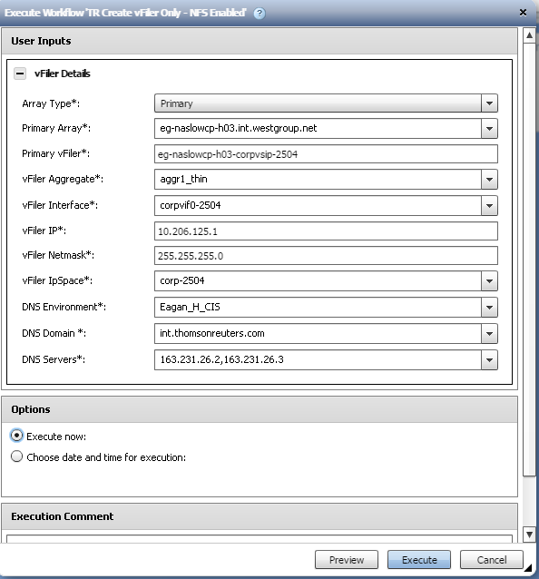
Mount filer and create backup (old DFMs will require the following to be done under sudo bash, dropping sudo)
- mount eg-naslowcp-h03:/ mt01

- cd mt01/etc

- sudo cp rc rc.CR01234567.2016.06.29

- sudo vim rc

Add/Modify the rc file with the updated info (Do not include #comments)

hostname eg-naslowcp-h03
ifgrp create lacp corpvif0 e0c e0e -b ip
vlan create corpvif0 2502
vlan add corpvif0 2504 #Add this line
ifconfig e0c flowcontrol none
ifconfig e0e flowcontrol none
ifconfig e0a `hostname`-e0a mediatype auto flowcontrol none netmask 255.255.255.0 partner e0a
ifconfig corpvif0-2502 10.206.123.176 netmask 255.255.254.0 mtusize 9000 partner corpvif0-2502
ifconfig corpvif0-2502 alias 10.206.123.187 netmask 255.255.254.0
ifconfig corpvif0-2502 alias 10.206.123.199 netmask 255.255.254.0
ifconfig corpvif0-2502 alias 10.206.123.207 netmask 255.255.254.0
ifconfig corpvif0-2502 alias 10.206.123.205 netmask 255.255.254.0
ifconfig corpvif0-2502 alias 10.206.123.211 netmask 255.255.254.0
ifconfig corpvif0-2504 10.206.125.1 netmask 255.255.255.0 mtusize 9000 partner corpvif0-2504 #Append mtusize and partner on the new interface first part of line will exist.
vfiler run eg-naslowcp-h03-corpvsip-2502 route add default 10.206.123.254 1
vfiler run eg-naslowcp-h03-corpvsip-2504 route add default 10.206.125.254 1 #Add default route for the new vfiler, IP is the VLAN gateway
route add default 167.68.64.254 1
routed on
options dns.domainname int.westgroup.net
options dns.enable on
options nis.enable off
priv set -q diag; setflag wafl_reclaim_threshold_m 80; priv set
priv set -q diag; setflag wafl_reclaim_threshold_l 80; priv set
priv set -q diag; setflag wafl_reclaim_threshold_xl 80; priv set
priv set diag; setflag smb_enable_2_1 0; priv set
savecore

Save rc file.

Execute the updated mtusize and route on the filer:
- ssh eg-naslowcp-h03 ifconfig corpvif0-2504 10.206.125.1 netmask 255.255.255.0 mtusize 9000 partner corpvif0-2504

- ssh eg-naslowcp-h03 vfiler run eg-naslowcp-h03-corpvsip-2504 route add default 10.206.125.254 1

Test connectivity by ping gateway and DNS from the vfiler
- ssh eg-naslowcp-h03
- vfiler context eg-naslowcp-h03-corpvsip-2504
- ping 10.206.125.254
- ping 163.231.26.2

